# CS 255 System Design Document

This template lays out all the different sections that you need to complete for Project Two. Each section has guidance to prompt your thinking. You will need to continually reference the interview transcript as you work to make sure that you are addressing your client’s needs. There is no required length for the final document. Instead, the goal is to complete each section based on what your client’s needs are. Remove this note when you are finished, and replace all bracketed text with the relevant information.

## UML Diagrams

### UML Use Case Diagram

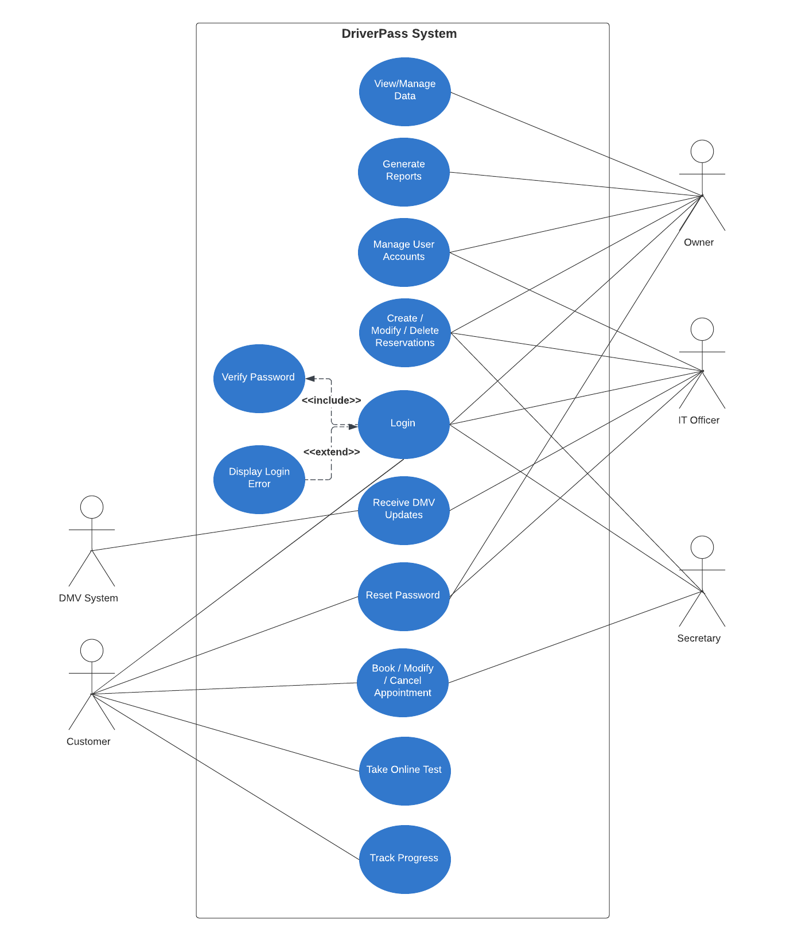

### UML Activity Diagrams

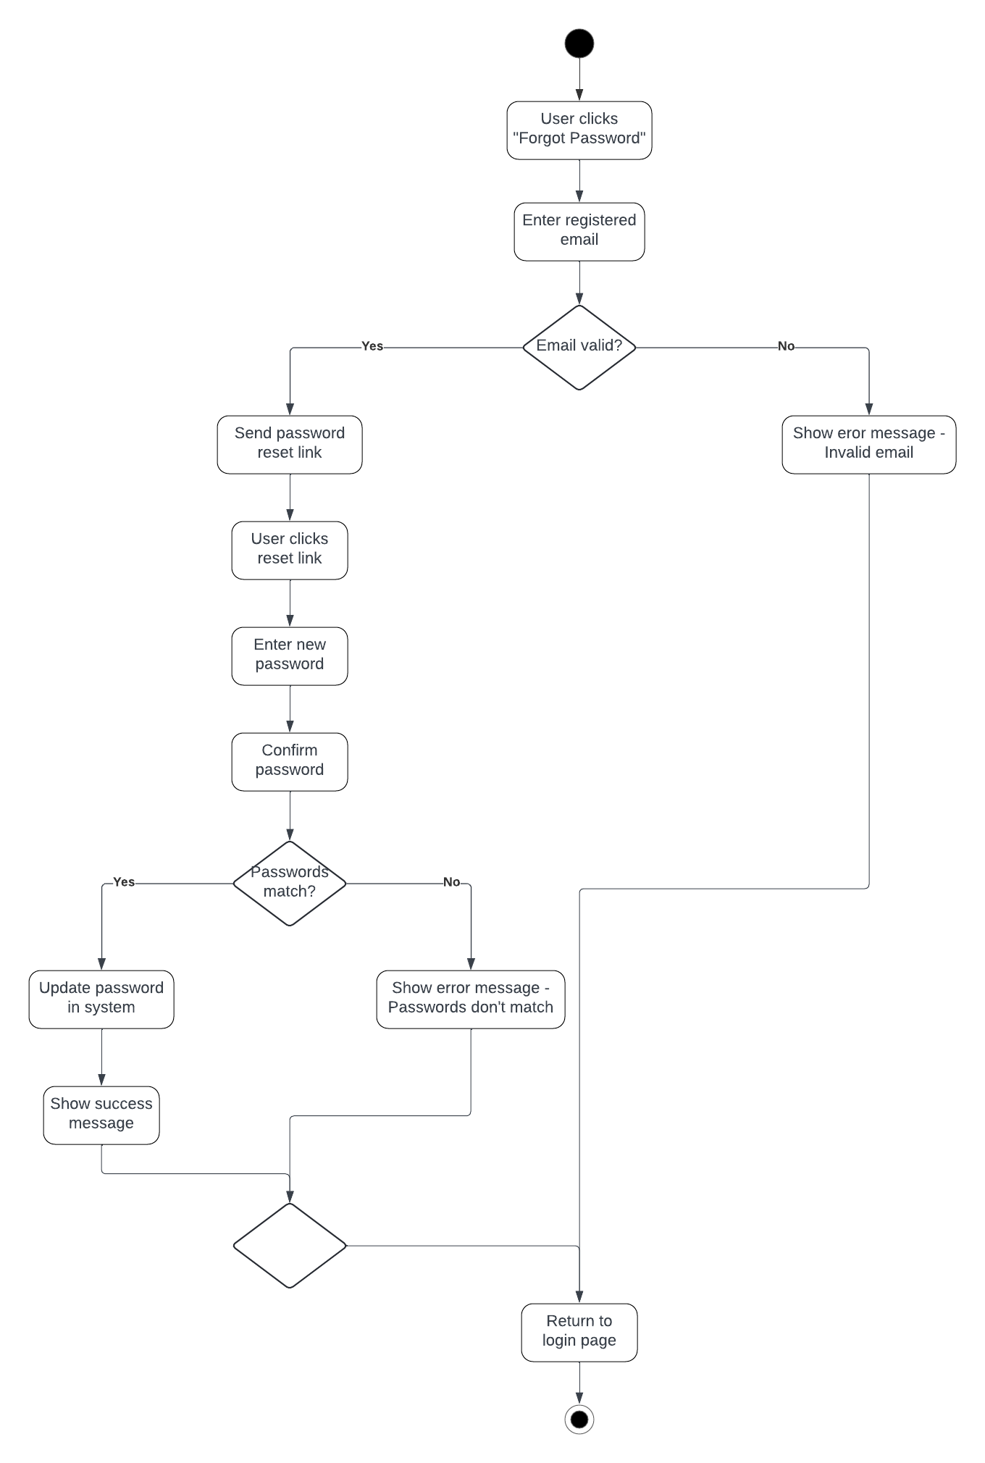

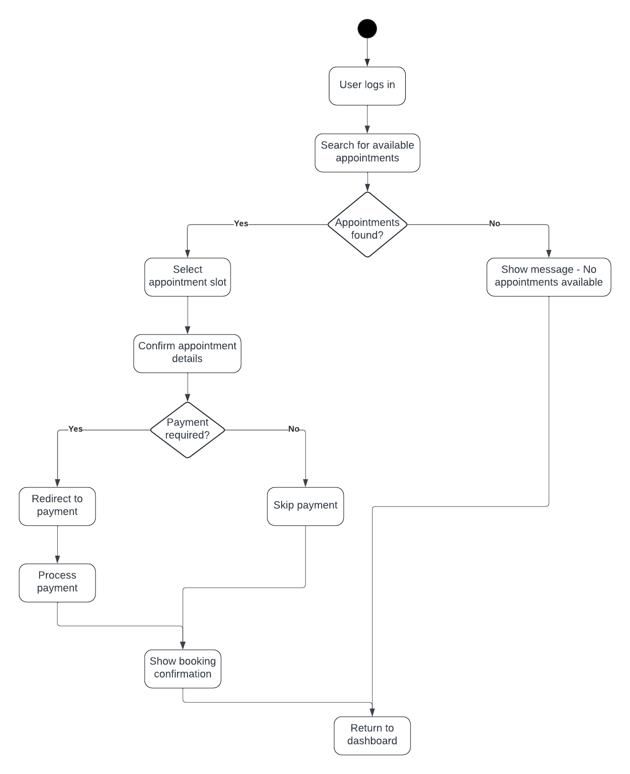

### UML Sequence Diagram

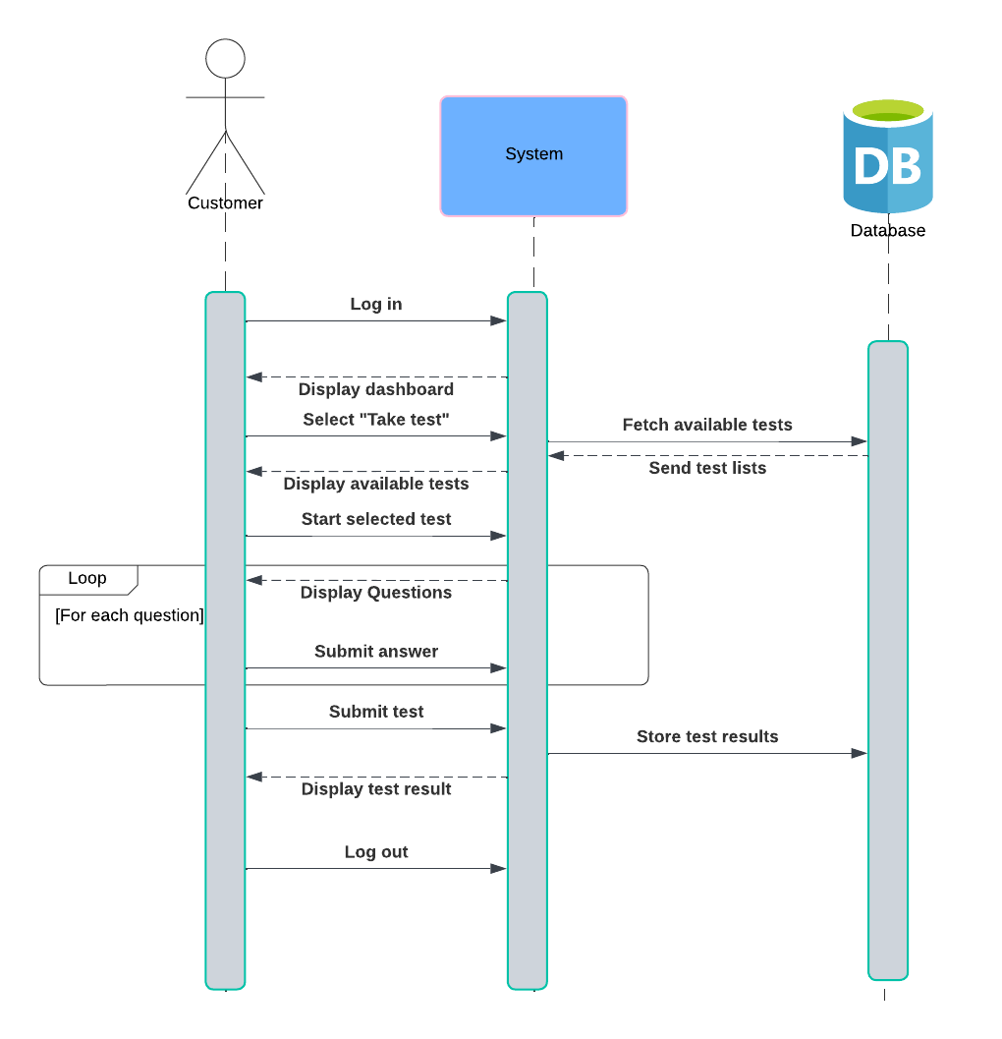

### UML Class Diagram

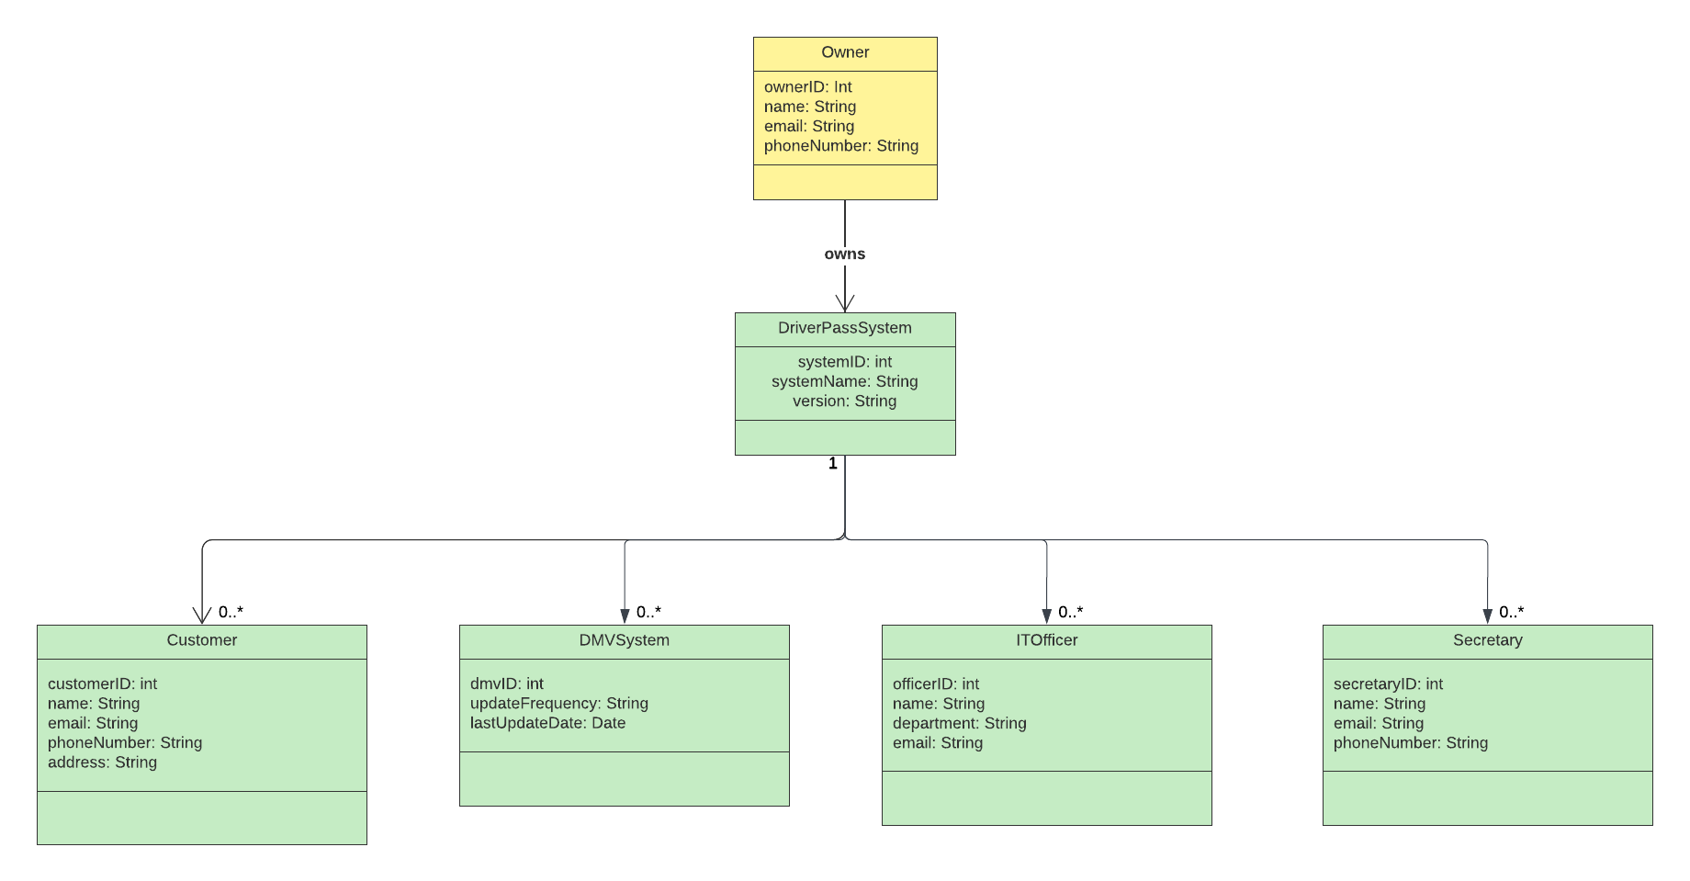

## Technical Requirements

Hardware requirements:

* Client devices: The system must be accessible from desktops, laptops, smartphones and tablets. The compatible devices include those running Windows, macOS, Android or iOS.
* Server requirements: Cloud-based services capable of hosting web applications.
* Networking: High-speed internet connectivity.

Software requirements:

* Operating System compatibility: The system must be browser-based and run on Google Chrome, Safari, Firefox or Microsoft Edge.
* Backend infrastructures: Cloud-based database services for managing user data, appointments, reports and driver lessons.
* APIs and Third-Party integrations: Use of DMV API for retrieving updates.

Tools and Infrastructures:

* Development tools: Development tools like version control system (GitHub) to manage source control. IDE and code editor to write code.
* Database requirements: Relational database such as MySQL to manage structured data. Real-time database update features.
* Encryption and Security: HTTPS secured connections between client and server. Encryption of sensitive data.